## Basics

### installations

python.org

anaconda.org

### IDEs Editors

pycharm

vscode

visual studio

jupyter

spyder

idle

### file extensions

.py core python files

.ipynb python notebooks

jupyter

spyder

### REPL

general programming concept

Read Eval Print Loop

### Keywords

True False

if elif else

while for

break continue

None del

### features :

-- everything is an object

-- even functions

### comments

# single line comments

docstring used as multi line comments

## Data Type

### regular:

int

float

str

complex

6 + 7j

### bool:

True

False

## Operators

### arithmetic

+

-

/

*

% remainder

// floor division

** power of

= assignment

### conditional (relational)

<

>

<=

>=

==

!=

### logical

and

or

not

### identity

is

is not

### membership

in

not in

## Functions

### general:

print

type

### sequences:

len()

sorted()

### cast (conversion):

int()

float()

str()

list()

tuple()

set()

## str

strings (text)

double or single quotes

index

IndexError (out of range)

negative

slicing

no IndexErrors

steps

| s | t | r | i | v | e | r |
| --- | --- | --- | --- | --- | --- | --- |
| 0 | 1 | 2 | 3 | 4 | 5 | 6 |
| -7 | -6 | -5 | -4 | -3 | -2 | -1 |

immutable

### str functions

lower, upper, capitalize, title

index, rindex, count

isalpha, isalnum, isdigit

replace

### escape sequences :

\n new line

\t tab

\b backspace

\\ \

\" "

obsolete

\v

\r

## list

any/all kinds of types

duplicates are allowed

index

IndexError (out of range)

negative

slicing

no IndexErrors

steps

mutable

references

nesting

any deep

### list functions

append, insert, extend

remove, pop, clear

sort, reverse

copy

count, index

## tuple

any/all kinds of types

duplicates are allowed

index

IndexError (out of range)

negative

slicing

no IndexErrors

steps

immutable

nesting

any deep

### tuple functions

count, index

## set

members

no duplicates

only unique

immutable

unordered

no index

no slice, no step

by itself is mutable

nesting not possible

### set operations

| union

& intersection (common )

- difference

^ symmetric diff (uncommon

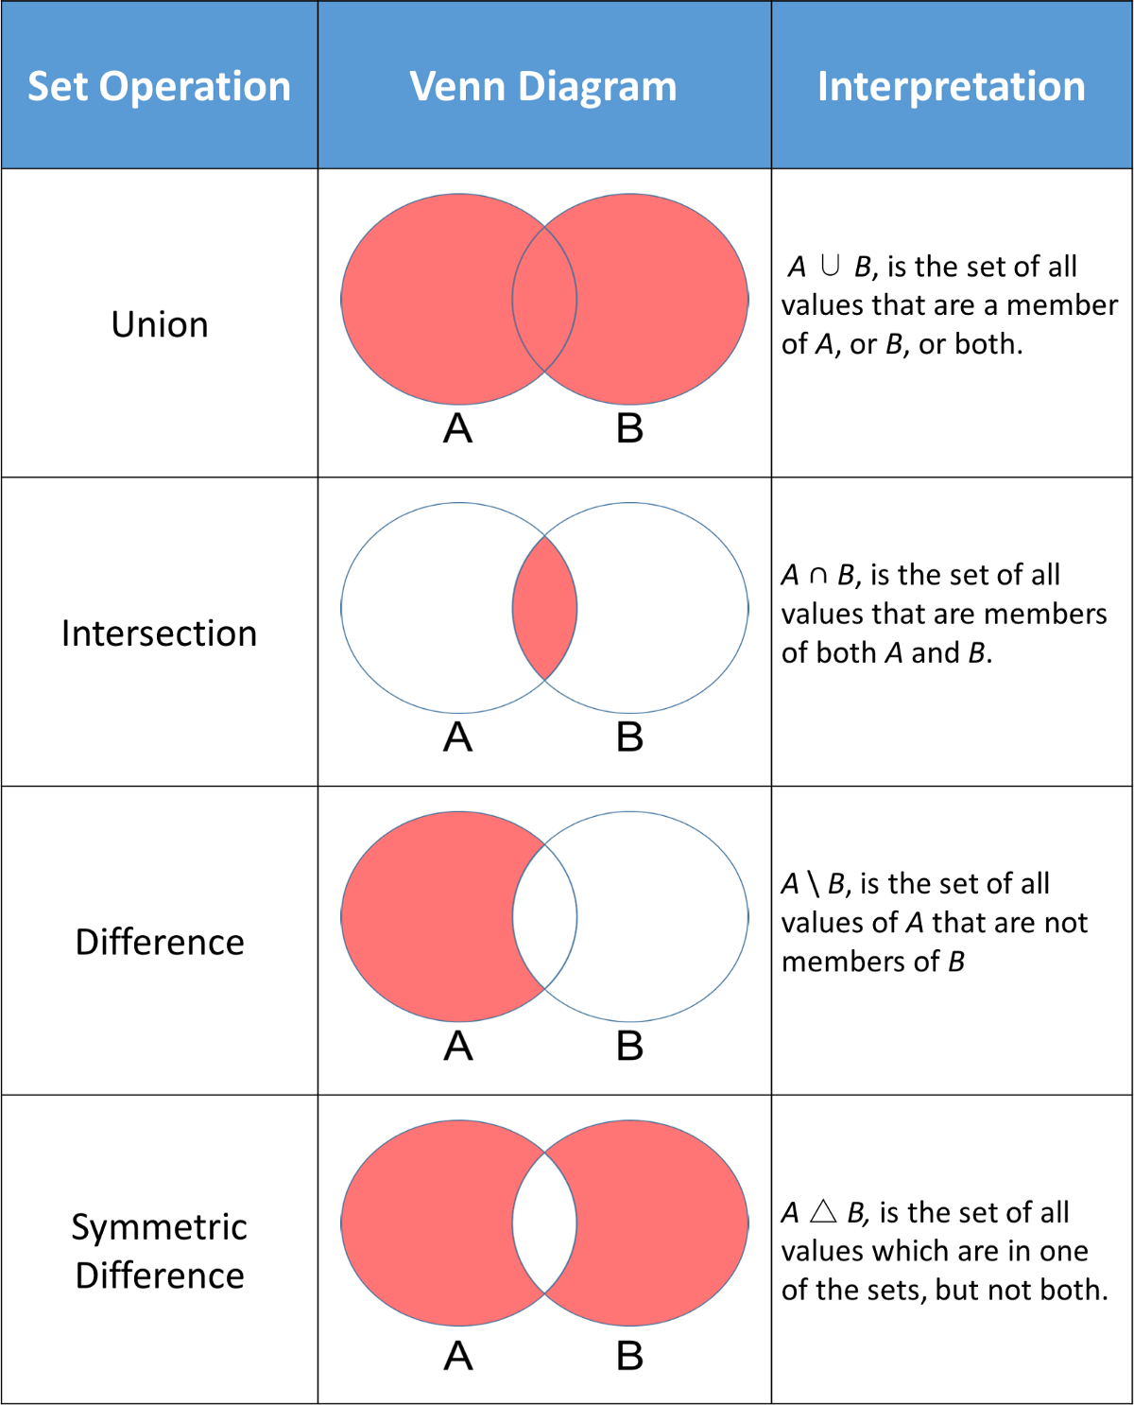

### set functions

intersection, intersection_update

discard ()

remove (throw an error is member does not exist)

pop (randomly)

clear()

## dict

key:value

ordered (3.7 +)

(older, till 3.6, unordered)

keys:

index

unique

immutable

int, strings, tuple

values:

anything

by itself, dict is mutable

### dict functions

update

## Flow Control

### if

if elif else

### while

while

while with else

### for

for with sequences

for with range

for with else

break continue

## functions

### return

any number

default is None

### parameters (arguments)

any number

### default argument

right most

### named argument

while calling the function

higher order

pure functions

modifiers

9949999239

[Mr.Nigam@gmail.com](mailto:Mr.Nigam@gmail.com)

extras:

if __name__ == “__main__”

pip

= = =